Computer Assignment-1

1. "Hello World" on console display

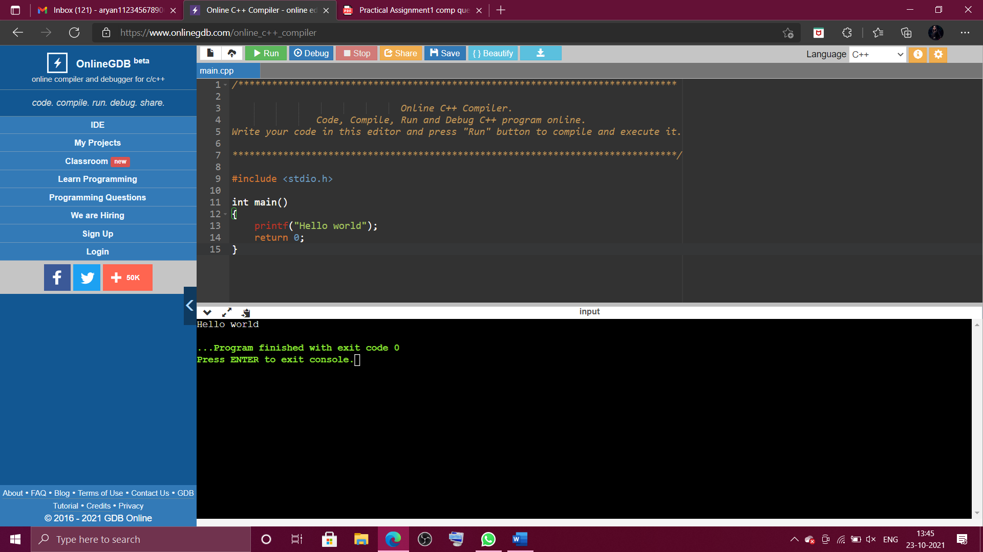

1. A character, integer, decimal number and display them.

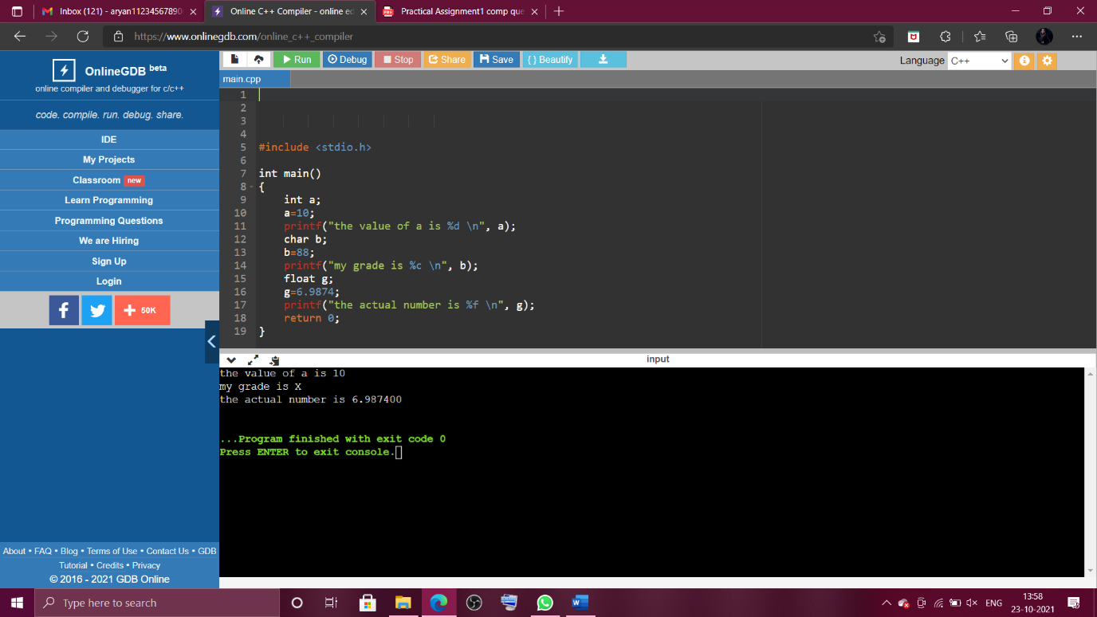

1. format console output using ‘\n’, ‘\t’, ‘\b’ within printf statement.

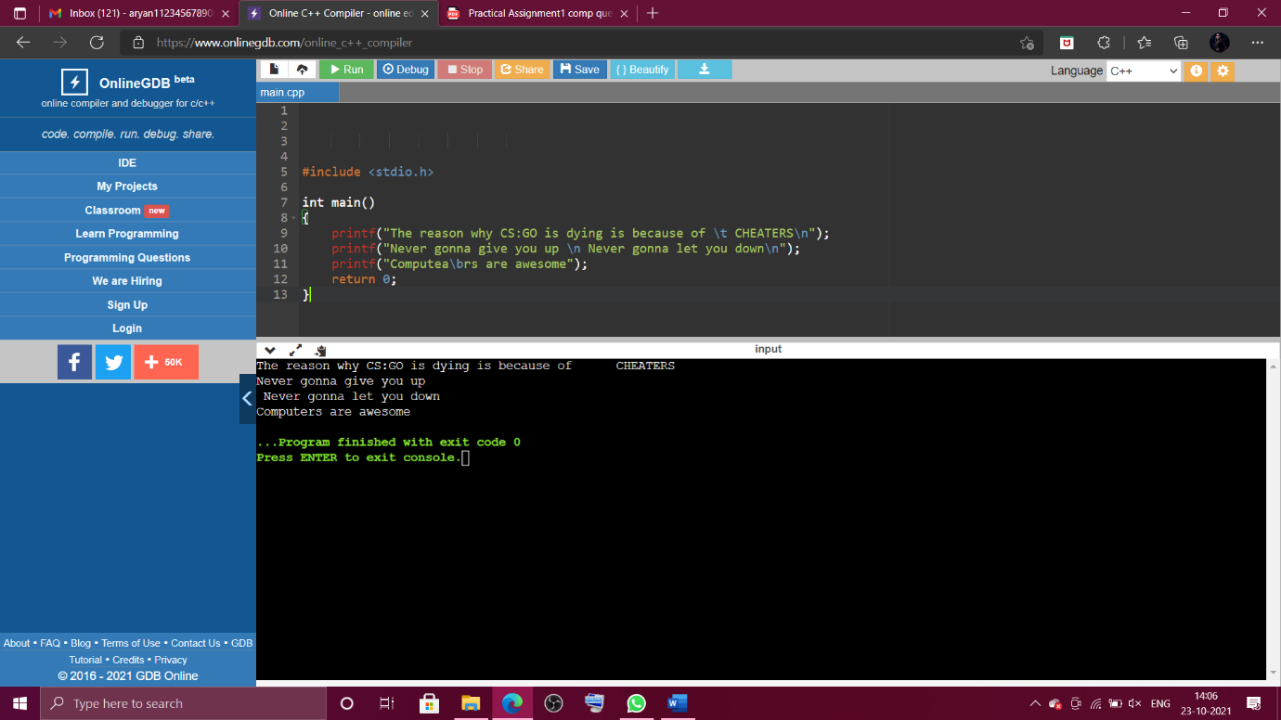

1. add, subtract, multiply, divide numbers.

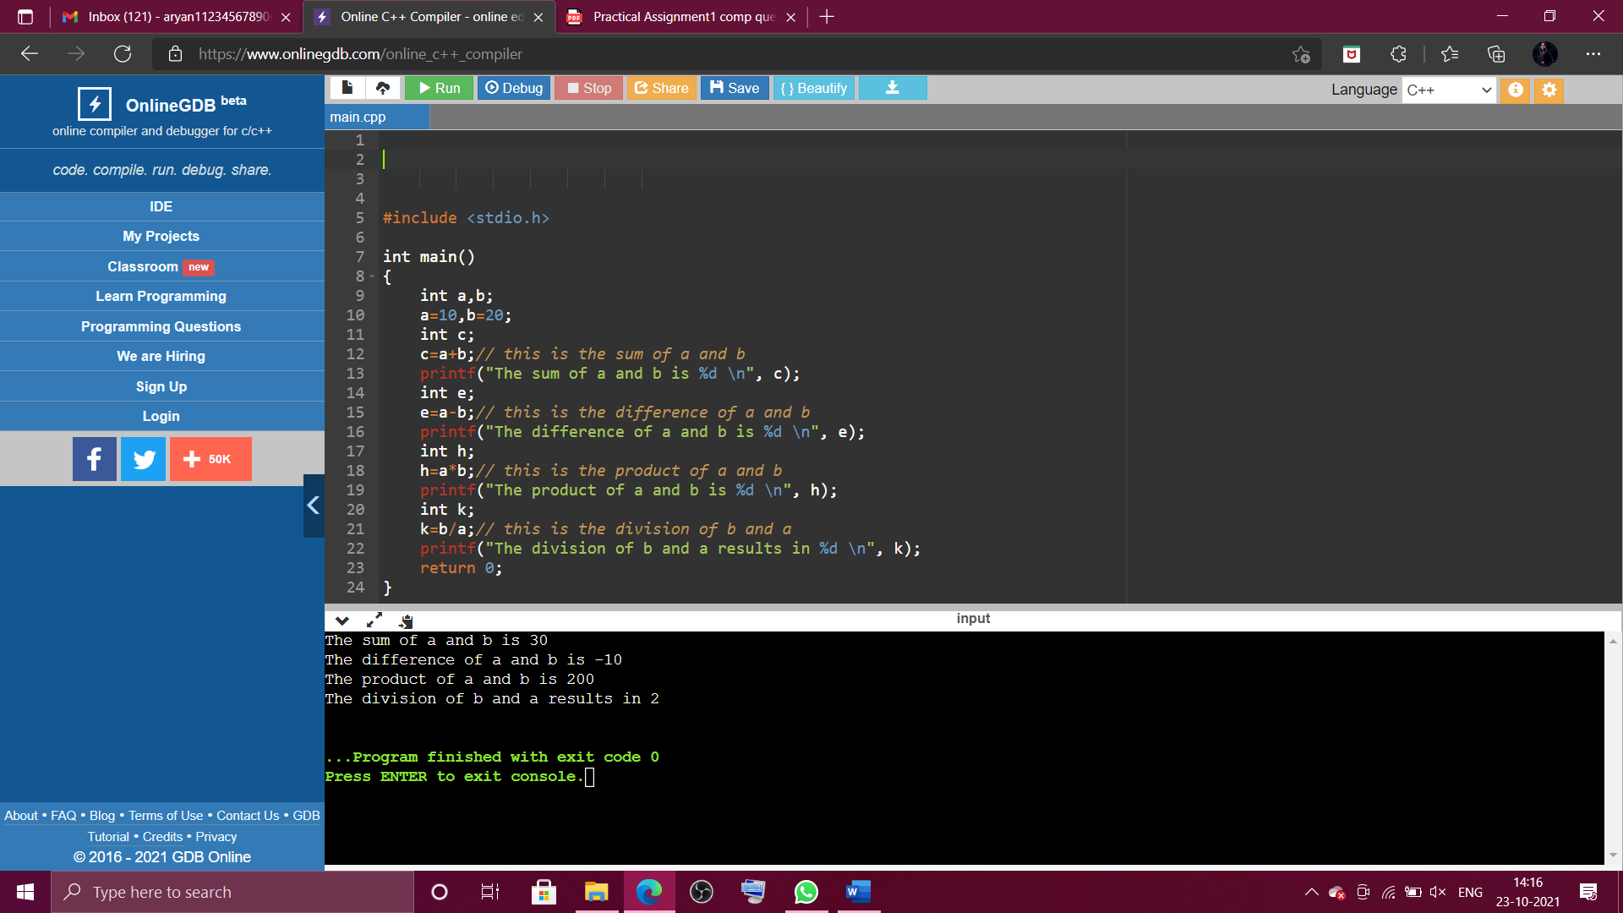

1. compute area of a circle by taking input from the user at run time using scanf()

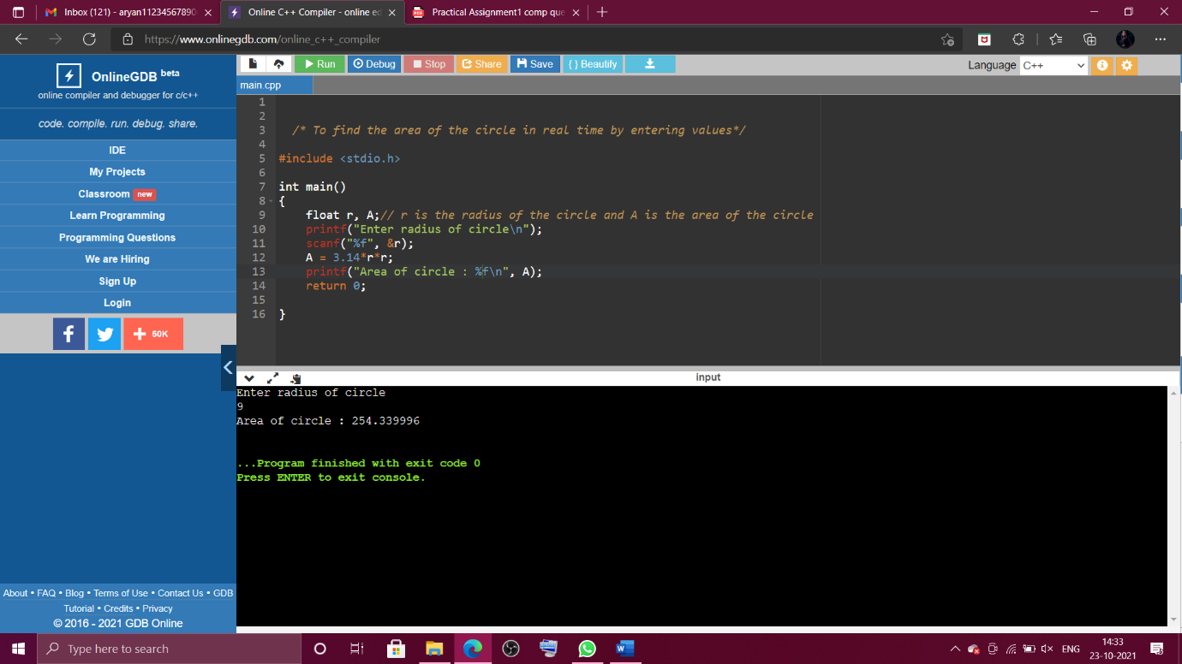

1. find Nth root of a number

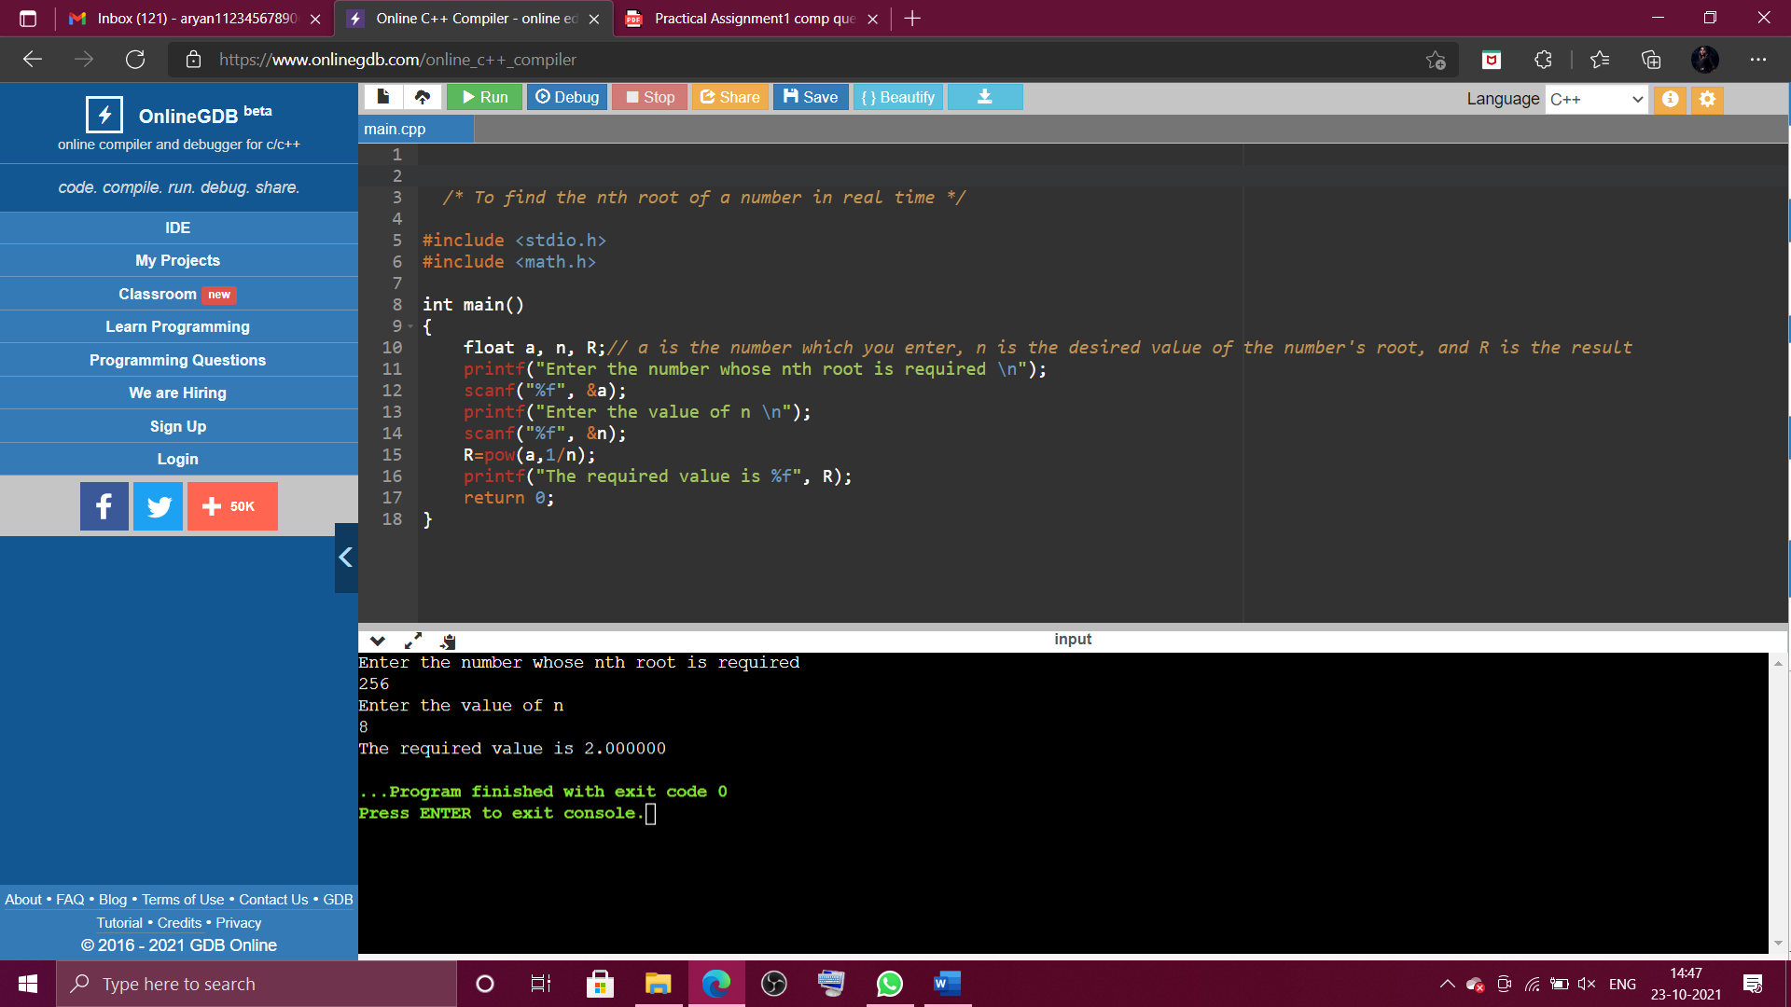

1. calculate gross salary of a person, where gross_salary=basic+da+ta and da is 10% of basic and ta is 12% of basic

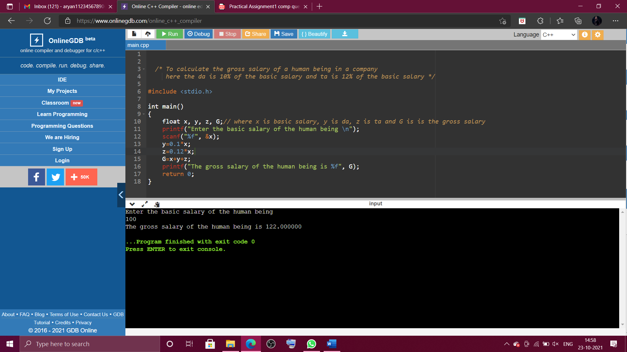

1. compute simple interest

